Assignment 3 Solution详解

1 Short Answers [必做，不用提交不算分数，后续公布答案后自行核对]
- [2pts] Explain overfitting and underfitting of machine learning models.
[2pts] Write down two aspects affecting the risk the overfitting.
[2pts] What strategies do decision trees use to reduce the risk of overfitting?
[2pts] What strategies do NNs use to reduce the risk of overfitting?
- [6pts] Derive Precision and Recall from confusion matrix (i.e., TP, TN, FP, FN). Write down the definition of F1 score given precision and recall.
- [6pts] Describe K-fold cross-validation. Are the error rates of different folds independent when K>2 and why?

Solutions

Overfitting and Underfitting
- Overfitting: Overfitting occurs when a machine learning model captures noise or random fluctuations in the training data instead of the underlying pattern. This results in excellent performance on the training data but poor generalization to new, unseen data. The model becomes overly complex, fitting the training data too closely.
- Underfitting: Underfitting happens when a machine learning model is too simple to capture the underlying pattern in the data. The model performs poorly on both the training data and new, unseen data because it fails to learn the relationships within the data.

Two Aspects Affecting the Risk of Overfitting
- Model Complexity: More complex models with more parameters are prone to overfitting. For instance, deeper neural networks or decision trees with many branches can fit the training data too closely.
- Amount of Training Data: A small or insufficient training dataset increases the risk of overfitting. With limited data, the model may capture noise and anomalies specific to the training set rather than general patterns.

Strategies Decision Trees Use to Reduce the Risk of Overfitting
- Pruning: Pruning involves cutting back the branches of the tree that have little importance, which simplifies the model and reduces complexity, preventing it from learning noise in the training data.
- Setting a Maximum Depth: Limiting the depth of the tree prevents it from becoming too complex. A shallower tree is less likely to overfit because it won't be able to model the noise and outliers in the training data.

Strategies Neural Networks (NNs) Use to Reduce the Risk of Overfitting
- Regularization: Techniques like L1 and L2 regularization add a penalty for large weights in the network's loss function. This discourages the model from becoming too complex and overfitting the training data.
- Dropout: Dropout is a technique where, during training, randomly selected neurons are ignored or dropped out. This prevents neurons from co-adapting too much, encouraging the network to generalize better to new data.

Precision
Out of all the positive predicted, what percentage is truly positive.
$$Precision= \frac{TP}{TP+FP}$$
Recall
Out of the total positive, what percentage are predicted positive.
$$Recall= \frac{TP}{TP+FN}$$
F1 Score
It is the harmonic mean of precision and recall.
$$F1 score= \frac{2}{\frac{1}{Precision}+\frac{1}{Recall}}=\frac{2*\left(Precision*Recall\right)}{Precision+Recall}$$

K-Fold Cross-Validation
K-fold cross-validation is a resampling procedure used to evaluate the performance of a machine learning model. The process involves the following steps:
- Splitting the Data: The dataset is divided into K equally-sized (or nearly equal) subsets, known as folds.
- Training and Validation: For each of the K iterations, one fold is set aside as the validation set, while the remaining K-1 folds are used to train the model.
- Evaluation: The model is trained on the training set and evaluated on the validation set. This process is repeated K times, with each fold serving as the validation set exactly once.
- Aggregating Results: The K results (e.g., error rates or accuracy scores) are averaged to produce a single performance metric, which is more reliable and robust than a single train-test split.
This method provides a better estimate of the model's performance on unseen data since it uses multiple train-test splits.

Independence of Error Rates Across Folds
When K > 2, the error rates of different folds are not completely independent. This is because:
- Overlap in Training Data: In each iteration, the training sets overlap significantly, sharing K-1/K portions of the data. This overlap means that the models trained in different folds are influenced by much of the same data, leading to correlated error rates.
- Shared Validation Data: Although each fold is used as a validation set exactly once, the way the data is split can introduce dependencies between the performance metrics of different folds. The model's performance on one fold might be indicative of its performance on other folds due to the inherent similarities and patterns in the data.
Thus, while K-fold cross-validation provides a comprehensive view of model performance, the error rates across different folds are not entirely independent due to the shared data used in training.

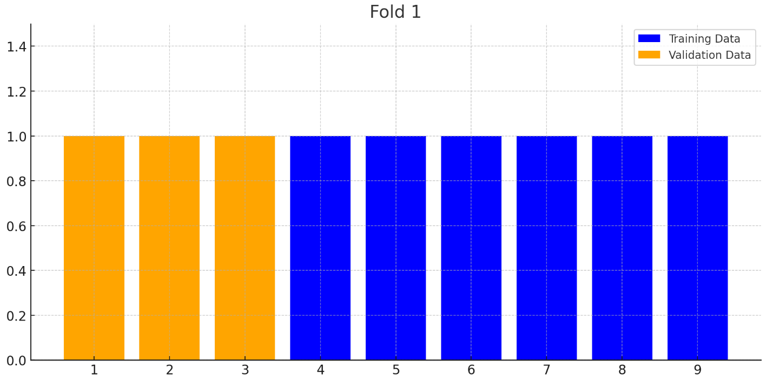
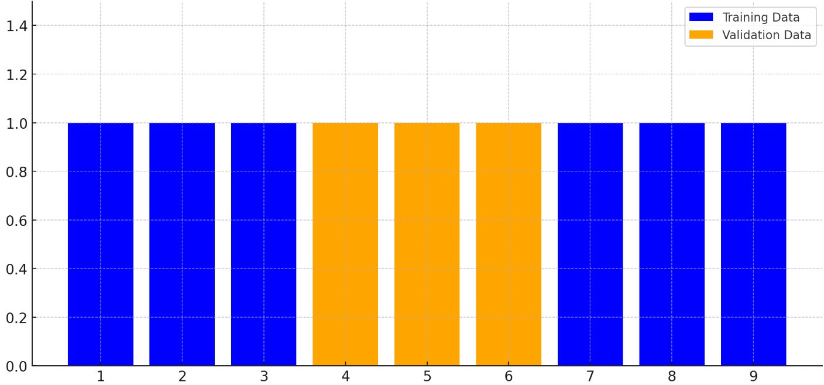
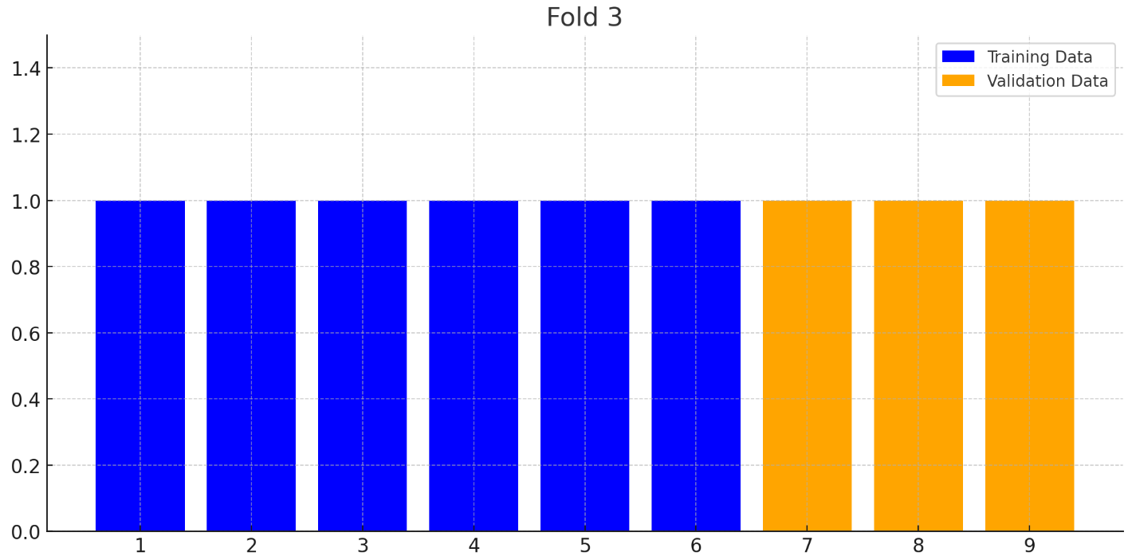

2 AUC [证明题，选做]
对于有限样例，请证明
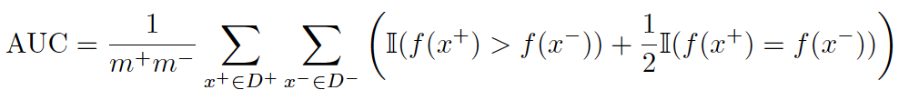

Proof. 此处用于写证明(中英⽂均可)

为了证明 AUC 公式，我们需要从 AUC 的定义开始。AUC（Area Under the Curve）通常用于评估二分类模型的性能，它是 ROC 曲线下面积。ROC 曲线是以假阳性率（FPR）为横坐标，真阳性率（TPR）为纵坐标绘制的曲线。

对于给定的二分类模型，AUC 可以被解释为随机选择一个正类样本和一个负类样本时，模型将正类样本的预测得分排在负类样本之前的概率。

定义和公式
AUC 的定义可以表示为：
$$\text{AUC}=\operatorname{Pr}\left(f\left(x^{+}\right)>f\left(x^{-}\right)\right)$$

其中 $x^{+}$ 是正类样本，$x^{-}$ 是负类样本。

公式推导

1. 定义总数：
考虑所有可能的正负样本对，总共有 $m^{+}×m^{-}$ 对，其中 $m^{+}$ 是正类样本数量， $m^{-}$ 是负类样本数量。

2. 指示函数：
定义指示函数 $I\left(f\left(x^{+}\right)>f\left(x^{-}\right)\right)$，如果 $f\left(x^{+}\right)>f\left(x^{-}\right)$，则 $I$ 取值为 1，否则为 0。

还需要考虑当 $f\left(x^{+}\right)=f\left(x^{-}\right)$ 时的情况，这时我们通常按一半概率计算，因此加入 $\frac{1}{2}I\left(f\left(x^{+}\right)=f\left(x^{-}\right)\right)$。

3. 公式表示：
对所有正负样本对进行求和：
$$\text{AUC}=\frac{1}{m^{+}m^{-}}\sum_{x^{+}∈D^{+}}{\sum_{x^{-}∈D^{-}}{\left(I\left(f\left(x^{+}\right)>f\left(x^{-}\right)\right)+\frac{1}{2}I\left(f\left(x^{+}\right)=f\left(x^{-}\right)\right)\right)}}$$



3. Friedman检验 [编程题，选做]
在数据集D1、D2、D3、D4、D5 上运行了A、B、C、D、E 五种算法，算法⽐较序值表如表1所⽰:
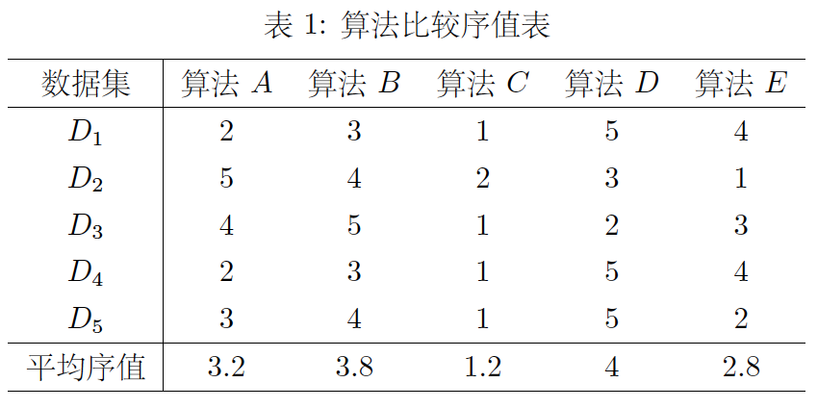
使⽤Friedman检验($α=0.05$) 判断这些算法是否性能都相同。若不相同，进⾏Nemenyi后
续检验($α=0.05$)，并说明性能最好的算法与哪些算法有显著差别。本题需编程实现Friedman检验和Nemenyi后续检验。(预计代码⾏数⼩于50 ⾏)

Solution

Friedman 检验是一种非参数统计检验方法，用于比较三个或更多相关样本组的中位数差异。这种检验方法特别适用于重复测量设计或块设计的实验数据，例如在同一组对象上对多种处理方法进行测量。

Friedman 统计量的公式为：
$$χ_{F}^{2}=\frac{12N}{k\left(k+1\right)}\left(\sum_{j=1}^{k}{R_{j}^{2}}\right)-3N\left(k+1\right)$$
其中：
- $N$ 是数据集的数量
- $k$ 是算法的数量
- $R_{j}$ 是第 $j$ 个算法的平均排名

代入公式计算：
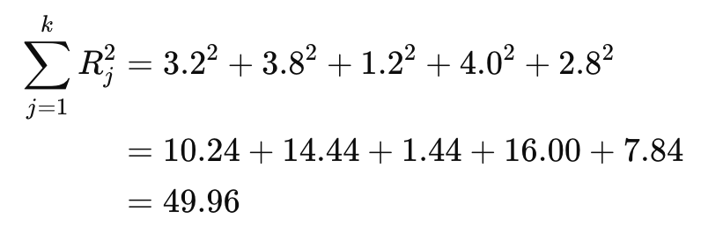
然后：
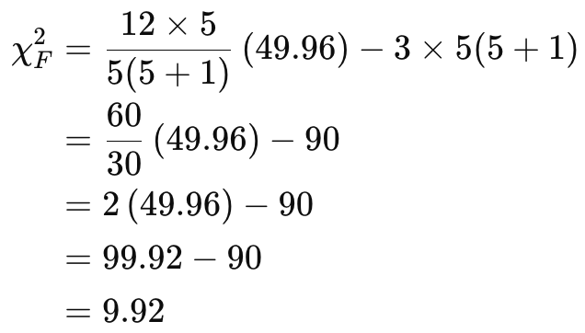
所以，Friedman 统计量为 $χ_{F}^{2}=9.92$。

计算 $p$ 值

Friedman 统计量 $χ_{F}^{2}$ 服从 $χ^{2}$ 分布，自由度为 $k-1$（这里 $k=5$，所以自由度为 4）。我们通过查表或使用统计软件计算对应的 $p$ 值：

对于 $χ^{2}$ 分布，自由度为 4，$χ_{F}^{2}=9.92$ 对应的 $p$ 值约为 0.0418。

我们拒绝原假设（即算法不存在性能差异），说明至少有两个算法在性能上存在显著差异。

Nemenyi 后续检验
Nemenyi 后续检验是一种非参数统计方法，用于在多个相关样本组的比较中，识别哪些样本组之间存在显著差异。该方法通常在 Friedman 检验之后使用，如果 Friedman 检验表明存在显著差异，则进行 Nemenyi 后续检验以确定具体的差异所在。

适用情况

- 在多个相关样本组之间进行比较时。
- 数据不满足正态分布假设，或使用了 Friedman 检验。
- 适用于配对比较。

基本步骤

1. 计算平均排名：对每个样本组的排名求平均值。

2. 计算临界差异 (CD)：
- 临界差异的公式为：
$$CD=q_{α}\sqrt{\frac{k\left(k+1\right)}{6N}}$$
其中：
- $q_{α}$ 是对应显著性水平 $α$ 和算法数量 $k$ 的临界值。
- $k$ 是算法的数量。
- $N$ 是数据集的数量。

3. 进行配对比较：计算每对样本组之间的排名差异，并与临界差异进行比较。如果差异超过临界差异，则认为这两个样本组之间存在显著差异。

Nemenyi 后续检验示例

假设我们有 5 个数据集和 5 种算法，经过 Friedman 检验后，我们发现存在显著差异。接下来，我们使用 Nemenyi 后续检验来确定具体的差异。

假设显著性水平 $α= 0.05$， $q_{α}=2.569$（从表中查得）。算法数量 $k = 5$，数据集数量 $N = 5$。

$$CD=2.569\sqrt{\frac{5⋅\left(5+1\right)}{6⋅5}}=2.569\sqrt{\frac{30}{30}}=2.569$$

进行配对比较：

计算每对算法之间的排名差异，并与临界差异进行比较：
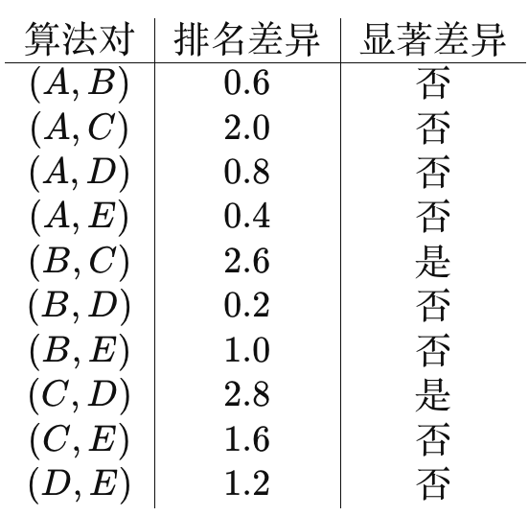

结论
- 算法 B 和算法 C 之间存在显著差异。
- 算法 C 和算法 D 之间存在显著差异。

Nemenyi 后续检验确定了算法 C 的性能显著优于算法 B 和算法 D。

Nemenyi 后续检验是识别多个相关样本组之间显著差异的有效方法，特别是在 Friedman 检验表明存在总体差异时。它通过计算平均排名和临界差异，对样本组进行配对比较，从而找出具体存在显著差异的样本组对。

- [25pts] Multi-layer Perception
Suppose that we apply neural networks on a problem which has boolean inputs $x∈{\left\{0,1\right\}}^{p}$ and boolean output $y∈0,1$. The network structure example is showed as below. In this example we set $p = 2$, single hidden layer with 2 neurons, activation function $ReLU\left(u\right)=u$ if $u > 0$ otherwise 0, and an additional threshold function (e.g., $f\left(v\right)=1$ if $v > 0$, otherwise $f\left(v\right)=0$) for output layer.
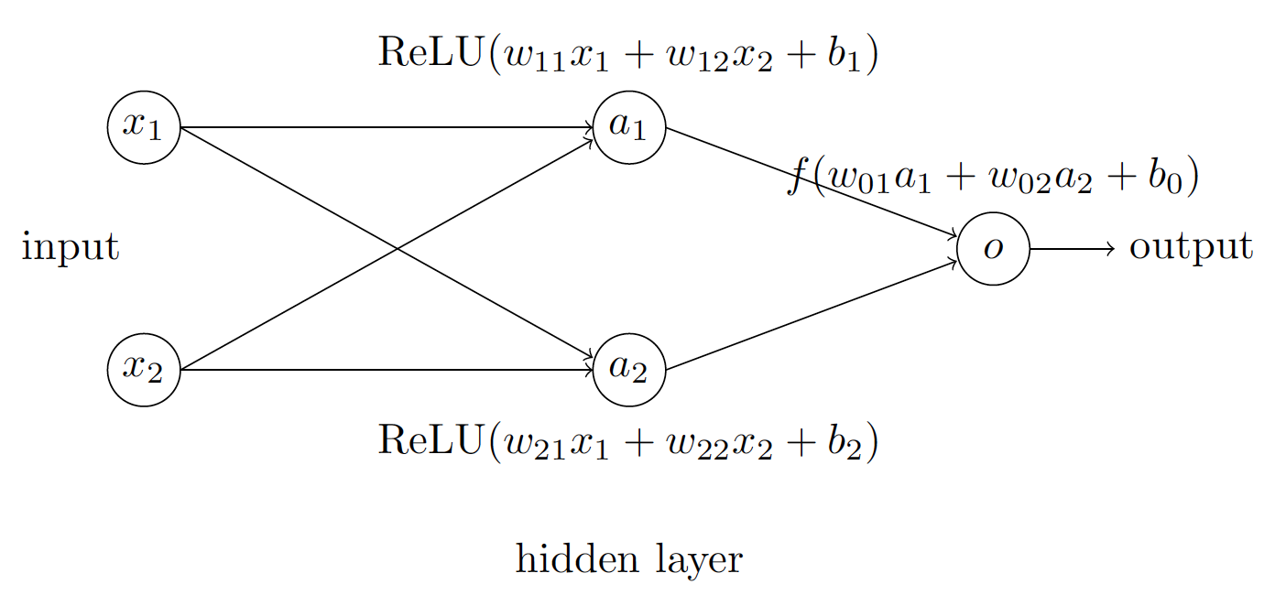
- [5pts] Using the structure and settings of neural network above, show that such a simple neural network could output the function $x1 XOR x2$ (equals to 0 if $x1 = x2$ and otherwise 1), which is impossible for linear models. State the values of parameters (i.e., $w_{ij}$ and $bi$) you found.

Solution:
输入是0或者1
$$a_{1}=ReLu\left(w_{11}x_{1}+w_{12}x_{2}+b_{1}\right)$$
$$a_{2}=ReLu\left(w_{21}x_{1}+w_{22}x_{2}+b_{2}\right)$$
$$y=I\left(w_{o1}a_{1}+w_{o2}a_{2}+b_{o}\right)$$

我们可以在$x_{1}=x_{2}$时，让其中$a_{1}$和$a_{2}$中的一个被激活，然后其它情况都不被激活。
这样的话，需要$b_{o}=1$来满足条件。

先从$x_{1}=0,x_{2}=0$开始，假设先让$a_{2}$激活：
$$a_{1}=ReLu\left(b_{1}\right)=0$$
$$a_{2}=ReLu\left(b_{2}\right)=b_{2}$$
$$y=I\left(w_{o1}a_{1}+w_{o2}a_{2}+b_{o}\right)=0$$
也就是$b_{2}>0$，但是$b_{1}≤0$。不妨直接设$b_{2}=1,b_{1}=-1$
$$w_{o2}+1≤0$$
得到$w_{o2}=-1$

然后考虑$x_{1}=1,x_{2}=1$，此时让$a_{1}$激活：
$$a_{1}=ReLu\left(w_{11}+w_{12}+b_{1}\right)=w_{11}+w_{12} -1$$
$$a_{2}=ReLu\left(w_{21}+w_{22}+1\right)=0$$
$$y=I\left(w_{o1}a_{1}+b_{o}\right)=0$$
$$w_{o1}\left(w_{11}+w_{12}+\left(-1\right)\right)+1≤0$$

$w_{21}+w_{22}<-1$，那么$w_{21}=w_{22}=-1$
由$w_{o1}\left(w_{11}+w_{12}+\left(-1\right)\right)+1≤0$可以看出，$w_{o1}<0$，不妨$w_{o1}=-1$，那么：
$$-w_{11}-w_{12}+1+1≤0$$
那么，$w_{11}=w_{12}=1$
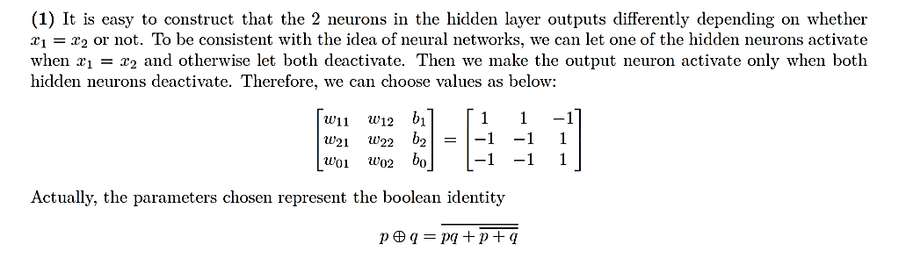
$$X=\left[\begin{matrix}0 & 0 & 1 & 1 \\ 0 & 1 & 0 & 1\end{matrix}\right]⟶y=\left[\begin{matrix}0 & 1 & 1 & 0\end{matrix}\right]$$

- [20pts] Now we allow the number of neurons in the hidden layer to be more than 2 but finite. Retain the structure and other settings. Show that such a neural network with single hidden layer could output an arbitrary binary function $h:{\left\{0,1\right\}}^{p}↦0,1$. You can apply threshold function after each neuron in the hidden layer.

为了展示一个单隐藏层的神经网络如何能够输出任意的二元函数 $h:\{0,1\}^{p}→\{0,1\}$ ，我们可以借鉴布尔代数中的理论，并使用逻辑门来实现各种布尔表达式。以下是详细的步骤和解释：

总体思路

1. 输入层: $x_{1},x_{2},…,x_{p}$
2. 隐藏层: 包含多个神经元，每个神经元对应一个逻辑表达式（例如AND门和OR门）。
3. 输出层: 组合隐藏层神经元的输出以产生最终的二进制输出。

方法
第一步：真值表表示
任何二元函数 $h:\{0,1\}^{p}→\{0,1\}$ 都可以用其真值表表示。对于 $p$ 个输入变量，真值表将有 $2^{p}$ 行，对应于所有可能的输入值组合。
第二步：隐藏层构建
隐藏层中的每个神经元可以配置为在特定的输入值组合下激活（输出为1）。这是通过设置适当的权重和偏置来实现的。具体地，每个隐藏层神经元可以被设计为识别输出为1的真值表中的一行。
第三步：输出层组合
输出层神经元将隐藏层神经元的输出通过逻辑或操作进行组合，从而得到最终的输出。

详细构建
1. 输入层: $x_{1},x_{2},…,x_{p}$
2. 隐藏层:
- 对于真值表中输出 $h\left(x\right)=1$ 的每一行，我们在隐藏层中创建一个神经元。
- 如果对于输入 $\left(a_{1},a_{2},…,a_{p}\right)$，期望输出为1，我们设置隐藏层神经元的权重和偏置使其仅在该输入下激活。
- 对于对应于输入 $\left(a_{1},a_{2},…,a_{p}\right)$ 的神经元：
$$\text{神经元输出}=\text{ReLU}\left(\sum_{i=1}^{p}{w_{i}x_{i}}+b\right)$$
其中，如果 $a_{i}=1$，则 $w_{i}=1$；如果 $a_{i}=0$，则 $w_{i}=-1$；且 $b=-\left(\sum_{i=1}^{p}{w_{i}}-1\right)$。

3. 输出层:
- 输出神经元对隐藏层神经元的输出执行逻辑或操作。
- 通过设置输出神经元的权重为1，并对每个隐藏层神经元应用阈值函数 $f\left(v\right)=1$ 如果 $v > 0$ ；否则 $f\left(v\right)=0$。

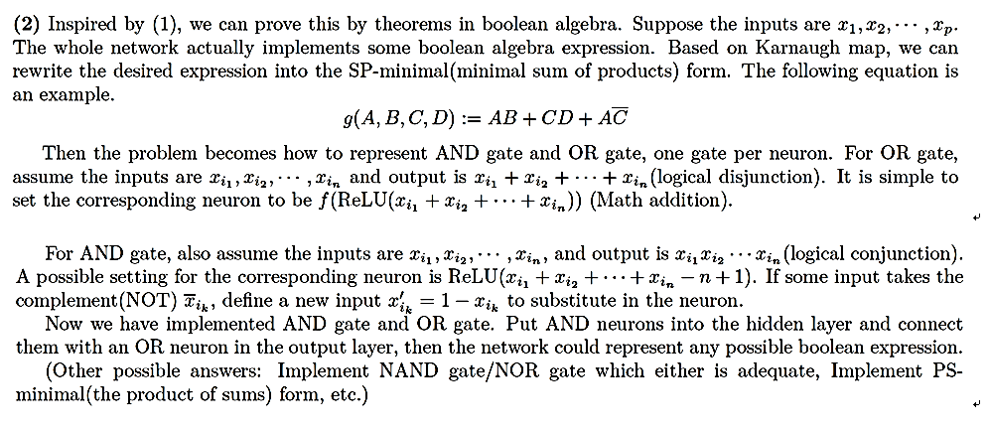
- [10pts] Gradient explosion and gradient vanishing
As shown in the figure below, the neural network has three hidden layers, each with only one neuron, and the activation function is the sigmoid function $σ\left(x\right)=\frac{1}{1+e^{-x}}$. Let the input be $x=3$. Use backpropagation to calculate the gradient, and experience the gradient explosion and gradient vanishing issues [1].
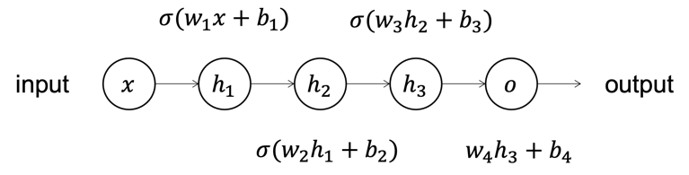

- [5pts] If $w_{1}=100,w_{2}=150, w_{3}=200, w_{4}=200, b_{1}=-300, b_{2}=-75, b_{3}=-100, b_{4}=10$, calculate the gradient $\frac{∂o}{∂b_{1}}$.
$$h_{1}=σ\left(w_{1}x+b_{1}\right)=σ\left(0\right)=\frac{1}{2}$$
$$h_{2}=σ\left(w_{2}h_{1}+b_{2}\right)=σ\left(0\right)=\frac{1}{2}$$
$$h_{2}=σ\left(w_{3}h_{2}+b_{3}\right)=σ\left(0\right)=\frac{1}{2}$$
$$o=w_{4}h_{3}+b_{4}=200×1/2+10=110$$
$$\frac{∂o}{∂b_{1}}=\frac{∂o}{∂h_{3}}⋅\frac{∂h_{3}}{∂h_{2}}⋅\frac{∂h_{2}}{∂h_{1}}⋅\frac{∂h_{1}}{∂b_{1}}=w_{4}⋅w_{3}σ^{'}\left(w_{3}h_{2}+b_{3}\right)⋅w_{2}σ^{'}\left(w_{2}h_{1}+b_{2}\right)⋅σ^{'}\left(w_{1}x+b_{1}\right)=w_{4}⋅\prod_{i=2}^{3}{w_{i}σ\left(w_{i}h_{i-1}+b_{i}\right)\left(1-σ\left(w_{i}h_{i-1}+b_{i}\right)\right)⋅}σ\left(w_{1}x+b_{1}\right)\left(1-σ\left(w_{1}x+b_{1}\right)\right)=w_{4}⋅\prod_{i=2}^{3}{w_{i}h_{i}\left(1-h_{i}\right)}⋅h_{1}\left(1-h_{1}\right)=93750$$

- [5pts] If $w_{1}=0.2,w_{2}=0.5, w_{3}=0.3, w_{4}=0.6, b_{1}=1, b_{2}=2, b_{3}=2, b_{4}=1$, calculate the gradient $\frac{∂o}{∂b_{1}}$.
$$h_{1}≈0.832,$$
$$h_{2}≈0.918,$$
$$h_{3}≈0.88,$$
$o=h_{4}≈1.828$.
$$\frac{∂o}{∂b_{1}}=w_{4}⋅\prod_{i=2}^{3}{w_{i}h_{i}\left(1-h_{i}\right)}⋅h_{1}\left(1-h_{1}\right)≈0.000100$$

- [25pts] CNN
Consider this one-dimensional convolutional neural network architecture.
In the first layer, we have a one-dimensional convolution with a single filter of size 3 such that $h_{i}=σ\left(\sum_{j=1}^{3}{v_{j}}x_{i+j-1}\right)$. The second layer is fully connected, such that $z=σ\left(\sum_{i=1}^{4}{w_{i}}h_{i}\right)$. The hidden units and output unit’s activation function $σ\left(x\right)$ is the logistic (sigmoid) function with derivative $σ^{'}\left(x\right)=σ\left(x\right)\left(1-σ\left(x\right)\right)$. We perform gradient descent on the loss function $L={\left(y-z\right)}^{2}$, where y is the training label for x.

- [5pts] What is the total number of parameters in this neural network? Recall that convolutional layers share weights. There are no bias terms.

1. Convolutional Layer: The convolutional layer has a single filter of size 3. Since convolutional filters share weights across the entire input, this filter has 3 parameters $v_{1},v_{2},v_{3}$, regardless of the number of times it is applied.
2. Fully Connected Layer: This layer connects each of the outputs from the convolutional layer to the output node. Since there are 4 hidden units $h_{1},h_{2},h_{3},h_{4}$ and each is connected to the output node $z$, there are 4 weights $w_{1},w_{2},w_{3},w_{4}$.
In total, the network has $3 + 4 = 7$ parameters. These consist of 3 weights from the convolutional filter and 4 weights in the fully connected layer. Note that there are no bias terms included in this model, as specified.

- [10pts] Compute $\frac{∂L}{∂w}$
Let $τ=h^{⊤}w$, then we have $z=σ\left(τ\right)$
$$\frac{∂L}{∂w}=\frac{∂L}{∂z}⋅\frac{∂z}{∂τ}⋅\frac{∂τ}{∂w}=-2\left(y-z\right)⋅z\left(1-z\right)⋅h=2\left(z-y\right)z\left(1-z\right)h$$

- [10pts] Compute $\frac{∂L}{∂v_{i}}$
$$\frac{∂L}{∂v_{i}}=\frac{∂L}{∂z}⋅\frac{∂z}{∂τ}⋅\sum_{j=1}^{4}{\frac{∂τ}{{∂h}_{j}}⋅\frac{∂h_{j}}{∂v^{T}x}⋅\frac{∂v^{T}x}{∂v_{i}}}=-2\left(y-z\right)⋅z\left(1-z\right)⋅\sum_{j=1}^{4}{w_{j}h_{j}\left(1-h_{j}\right)x_{i+j-1}}$$

- [30pts] CNN
As shown in the figure below, the neural network consists of a convolutional layer and a fully connected layer, with input as $X=\left(\begin{matrix}x_{11} & \begin{matrix}x_{12} & x_{13}\end{matrix} \\ \begin{matrix}x_{21} \\ x_{31}\end{matrix} & \begin{matrix}\begin{matrix}x_{22} \\ x_{32}\end{matrix} & \begin{matrix}x_{23} \\ x_{33}\end{matrix}\end{matrix}\end{matrix}\right)$, convolutional kernel (filter) as $K=\left(\begin{matrix}k_{11} & k_{12} \\ k_{21} & k_{22}\end{matrix}\right)$, convolution result as Y =$K*X=\left(\begin{matrix}y_{11} & y_{12} \\ y_{21} & y_{22}\end{matrix}\right)$, and output as $o=σ\left(w_{11}y_{11}+w_{12}y_{12}+w_{21}y_{21}+w_{22}y_{22}\right)$, $σ$ is sigmoid function. The sample label is $z$, and $E$ is the mean squared error ($E=\frac{1}{2}{\left\|z-o\right\|}^{2}$). Find the derivative of the convolutional kernel [2].

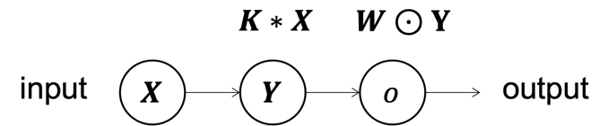

Where, “*” is convolution, “$⊙$” is Hadamard product which is element-wise product.

$$\frac{∂E}{∂K}=\frac{∂E}{∂o}⋅\frac{∂o}{∂Y}⋅\frac{∂Y}{∂K}=\left(z-o\right)⋅σ^{'}\left(W⊙Y\right)W⋅X$$
$$=\left(z-o\right)⋅o\left(1-o\right)⋅W⋅X$$

- [30pts] RNN: BPTT
Provide the detailed derivation process of the BPTT (Backpropagation Through Time) algorithm, ensuring that the symbols are consistent with those in the Lecture PPT.
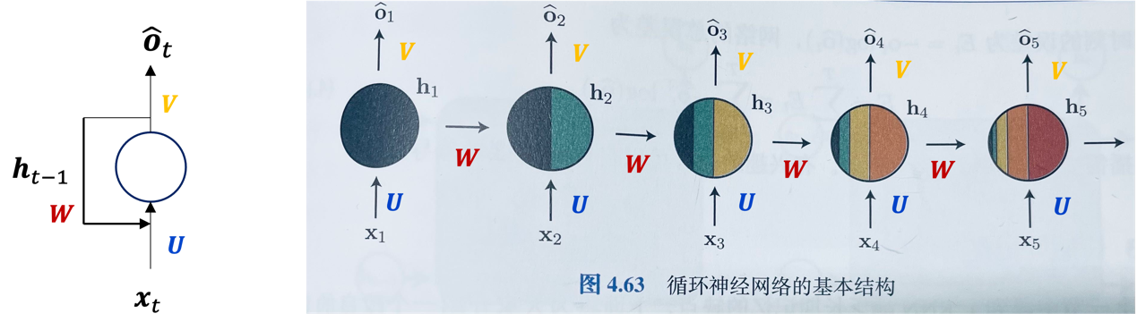

前向传播 (Forward Pass)
首先，定义前向传播过程中的公式和符号：
1. 隐藏状态计算 (Hidden State Computation):
$$h_{t}=σ\left(Ux_{t}+Wh_{t-1}+b_{h}\right)$$
这里， $U$ 是输入到隐藏层的权重矩阵，W 是隐藏层到隐藏层的权重矩阵，$b_{h}$ 是隐藏层的偏置，$σ$ 是激活函数。
2. 输出计算 (Output Computation):
$o_{t}=Vh_{t}+b_{o}$
这里，$V$ 是隐藏层到输出层的权重矩阵， $b_{o}$ 是输出层的偏置。
3. 损失计算 (Loss Computation):
$L_{t}=\text{loss}\left(o_{t},y_{t}\right)$
这里，$L_{t}$ 是时间步 $t$ 的损失函数。

时间展开 (Unrolling in Time)
为了应用 BPTT，我们将 RNN 在 $T$ 个时间步上展开，这样可以将其视为具有共享权重的前馈网络。
反向传播 (Backward Pass)
目标是计算损失相对于权重的梯度。我们推导 $U$、$W$ 和 $V$ 的梯度。
相对于 $V$ 的梯度
- 总损失:
$$L=\sum_{t=1}^{T}{L_{t}}$$

2. 损失相对于 $o_{t}$ 的梯度:
$$\frac{∂L}{∂o_{t}}=\frac{∂L_{t}}{∂o_{t}}$$

3. $o_{t}$ 相对于 $V$ 的梯度:
$$\frac{∂o_{t}}{∂V}=h_{t}$$

4. 使用链式法则:
$$\frac{∂L}{∂V}=\sum_{t=1}^{T}{\frac{∂L_{t}}{∂o_{t}}}⋅\frac{∂o_{t}}{∂V}=\sum_{t=1}^{T}{\frac{∂L_{t}}{∂o_{t}}}h_{t}^{⊤}$$

相对于 $U$ 和 $W$ 的梯度
1. 损失相对于 $h_{t}$ 的梯度:
$$δ_{t}^{h}=\frac{∂L}{∂h_{t}}=\frac{∂L_{t}}{∂o_{t}}⋅V^{⊤}+δ_{t+1}^{h}⋅W^{⊤}⊙σ^{'}\left(h_{t}\right)$$
这里，$⊙$表示元素逐个相乘，$σ^{'}$ 是激活函数的导数。
2. $h_{t}$ 相对于 $U$ 的梯度:
$$\frac{∂h_{t}}{∂U}=x_{t}^{⊤}$$
3. 使用链式法则:
$$\frac{∂L}{∂U}=\sum_{t=1}^{T}{δ_{t}^{h}}⋅\frac{∂h_{t}}{∂U}=\sum_{t=1}^{T}{δ_{t}^{h}x_{t}^{⊤}}$$
4. $h_{t}$相对于 $W$的梯度:
$$\frac{∂h_{t}}{∂W}=h_{t-1}^{⊤}$$
5. 使用链式法则:
$$\frac{∂L}{∂W}=\sum_{t=1}^{T}{δ_{t}^{h}}⋅\frac{∂h_{t}}{∂W}=\sum_{t=1}^{T}{δ_{t}^{h}h_{t-1}^{⊤}}$$

总结来说，使用 BPTT 计算 RNN 中权重的梯度如下：
- 对于 $V$：
$$\frac{∂L}{∂V}=\sum_{t=1}^{T}{\frac{∂L_{t}}{∂o_{t}}}h_{t}^{⊤}$$

- 对于 $U$：
$$\frac{∂L}{∂U}=\sum_{t=1}^{T}{δ_{t}^{h}x_{t}^{⊤}}$$

- 对于 $W$：
$$\frac{∂L}{∂W}=\sum_{t=1}^{T}{δ_{t}^{h}h_{t-1}^{⊤}}$$

